Chapter 10, Problem 93.

Fig. 10.135 shows a Colpitts oscillator. Show that the oscillation frequency is

f_{o} = 1/[2π√(LC_{T})]

where C_{T} = (C₁C₂)/(C₁ + C₂). Assume R_{i} >> X_{C2}.
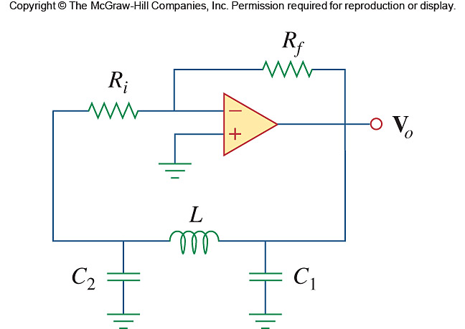

Figure 10.135
For Prob. 10.93.

